**Test Case 15**

**System:** Bench

**Description:** Test that the user is able to show/see the average of rating for a user.

**Severity:** 3

**Instructions**

**Test 1**

1. Start the Bench application.
2. Click the button “Login” on the navigation bar.
3. Enter the email “team23project@gmail.com” into the text field labeled “Email address”.
4. Enter the password “12345678” into the field labeled “Password”.
5. Click the button “Login” below the field.
6. After the screen has loaded, click on the button “My Profile” on the navigation bar.

**Expected Result:** There should be a panel labeled “Average Rating” where the user is allowed to view their own average rating.

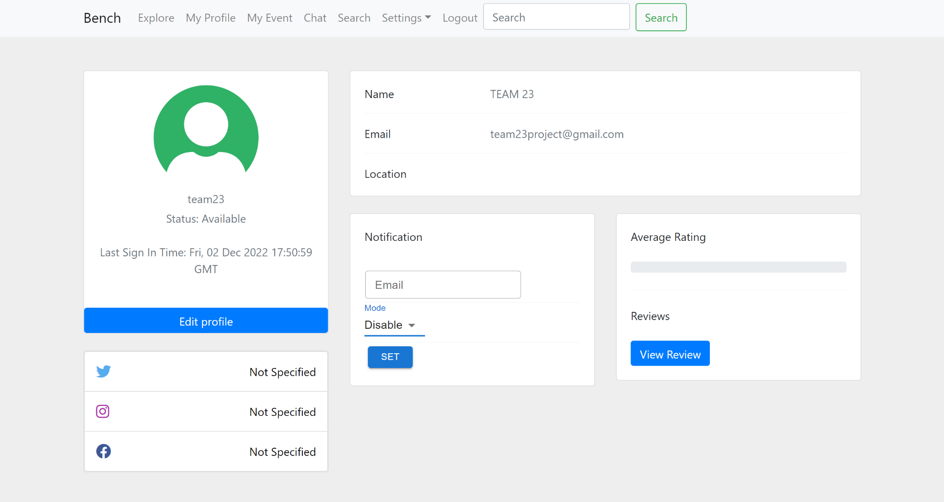

**Test 2**

1. Start the Bench application.
2. Click the button “Login” on the navigation bar.
3. Enter the email “team23project@gmail.com” into the text field labeled “Email address”.
4. Enter the password “12345678” into the field labeled “Password”.
5. Click the button “Login” below the field.
6. After the screen has loaded, click on the button “View Profile” on any of the other users shown on the Explore page.

**Expected Result:** There should be a panel labeled “Average Rating” where the user is allowed to view the particular user’s average rating.

